Business Question and Visualization Report

Date

17

feb 2026

Team ID

LTVIP2026TMIDS25024

Project Name

Visualizing Housing Market Trends: An
Analysis of Sale Prices and Features using
Tableau

Maximum Marks

5
Marks

- What is the average sale price of houses?

Visualization: Summary dashboard showing the average sale price of houses.

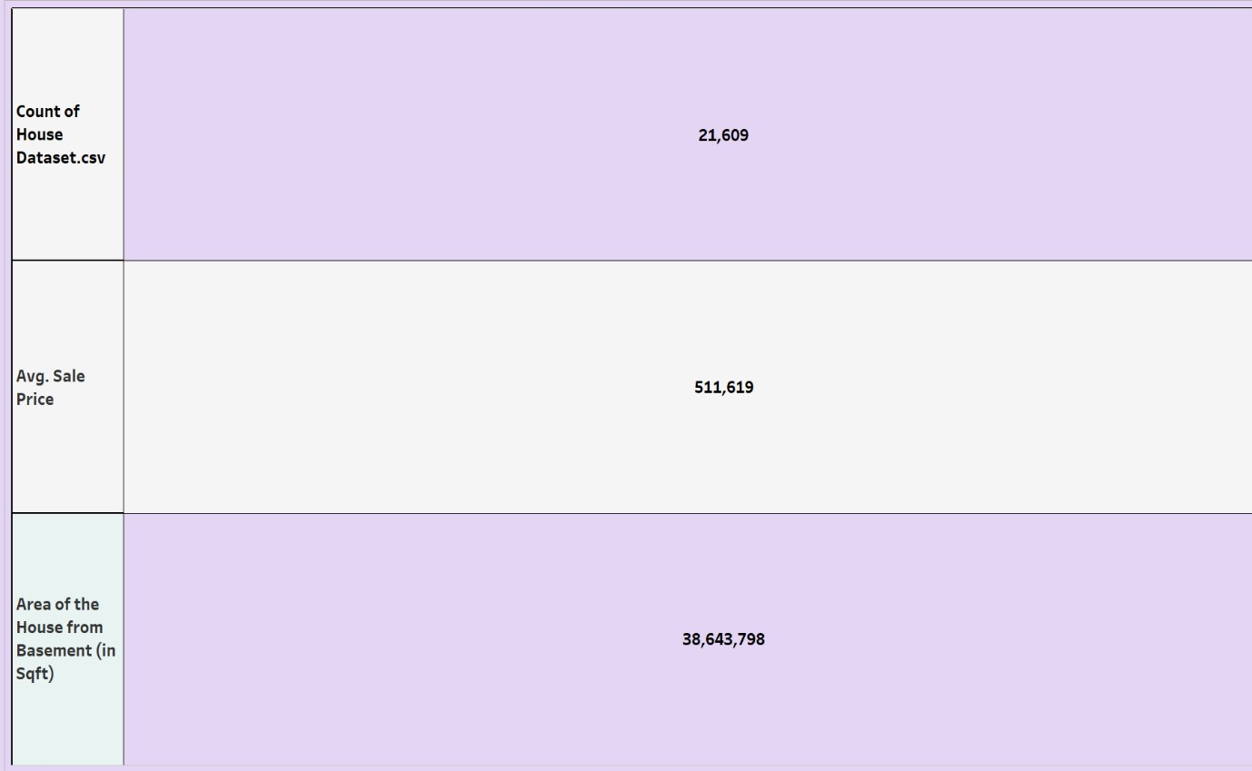

- Which basement size shows the highest sale price?

Visualization: Bar chart showing the highest sale price.

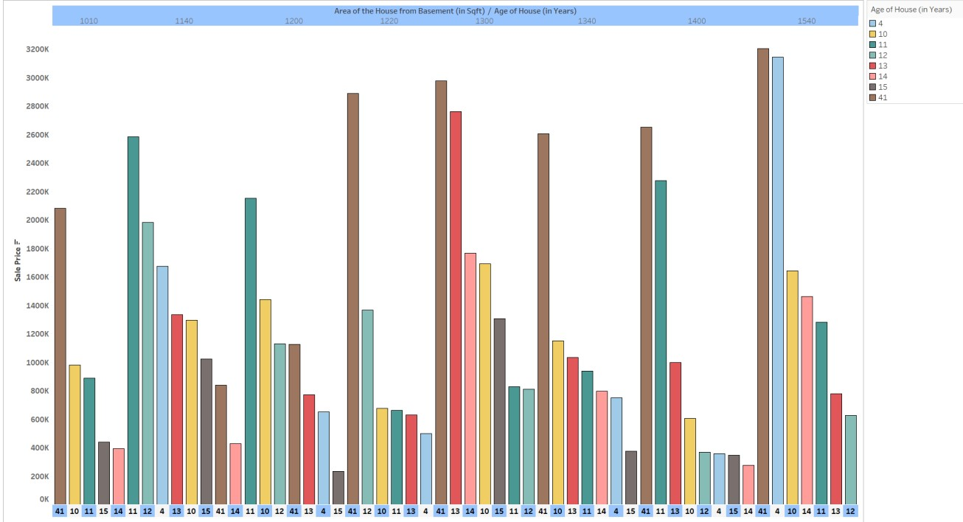

- Which price range has the lowest number of sales?

Visualization: Bar chart showing the lowest number of sales.

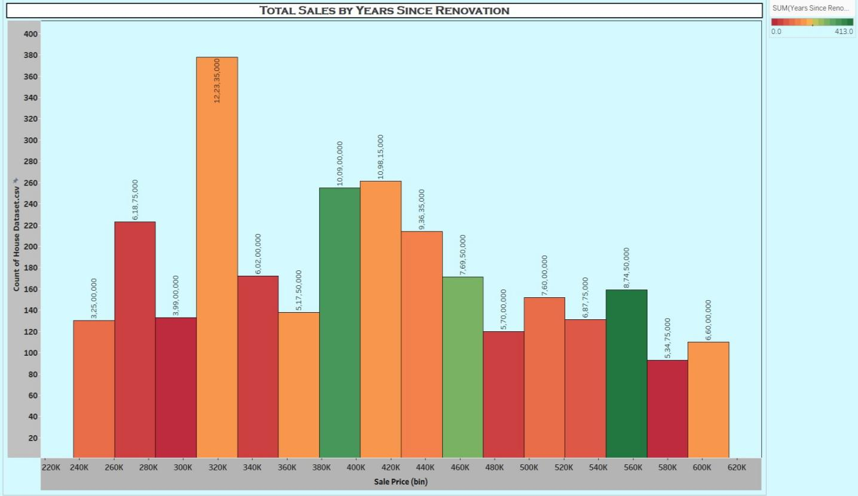

- What does the color coding represent?

Visualization: Line chart represents different house ages.

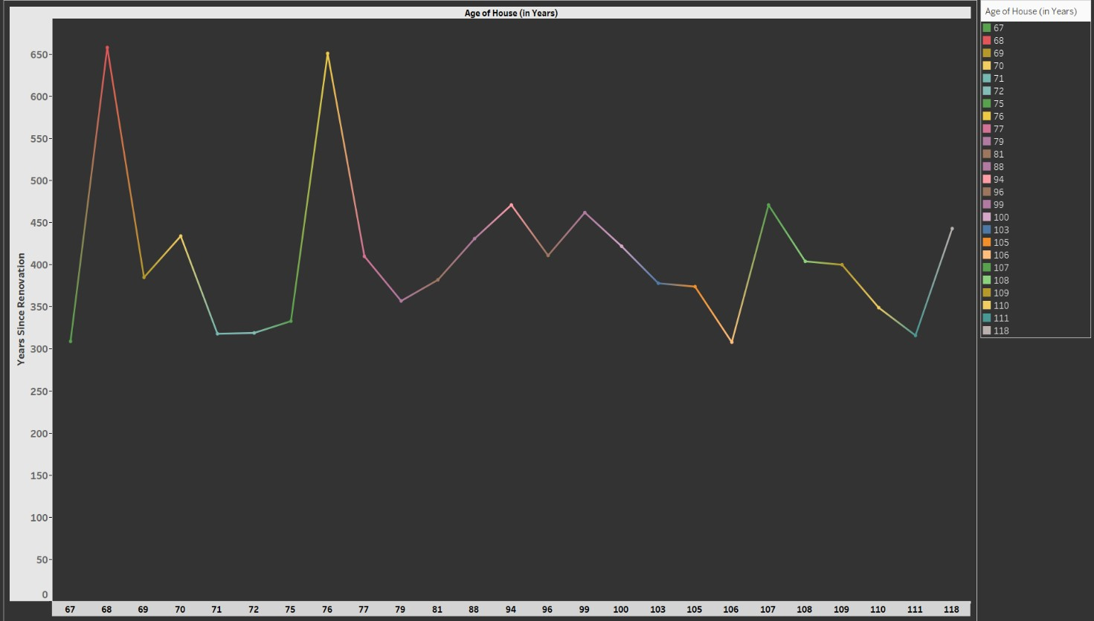

- How many different houses age categories are shown?

Visualization: Pie chart showing the different houses age categories.

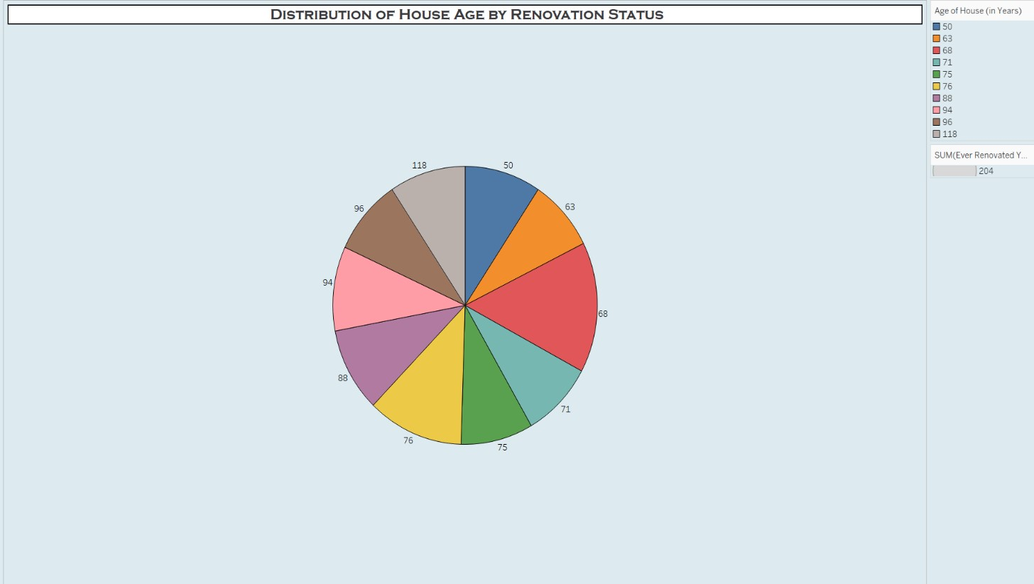

- What age groups of houses are included in the chart?

Visualization: Bar chart shows the age group of houses.

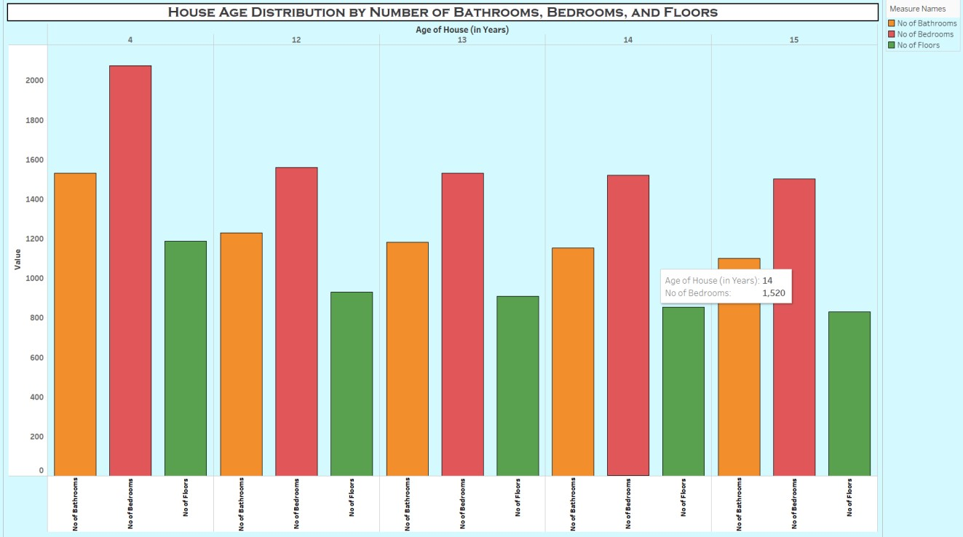

- What is the count of houses in the dataset for each house age?

Visualization: Text table show the count of houses in the dataset for each house age.

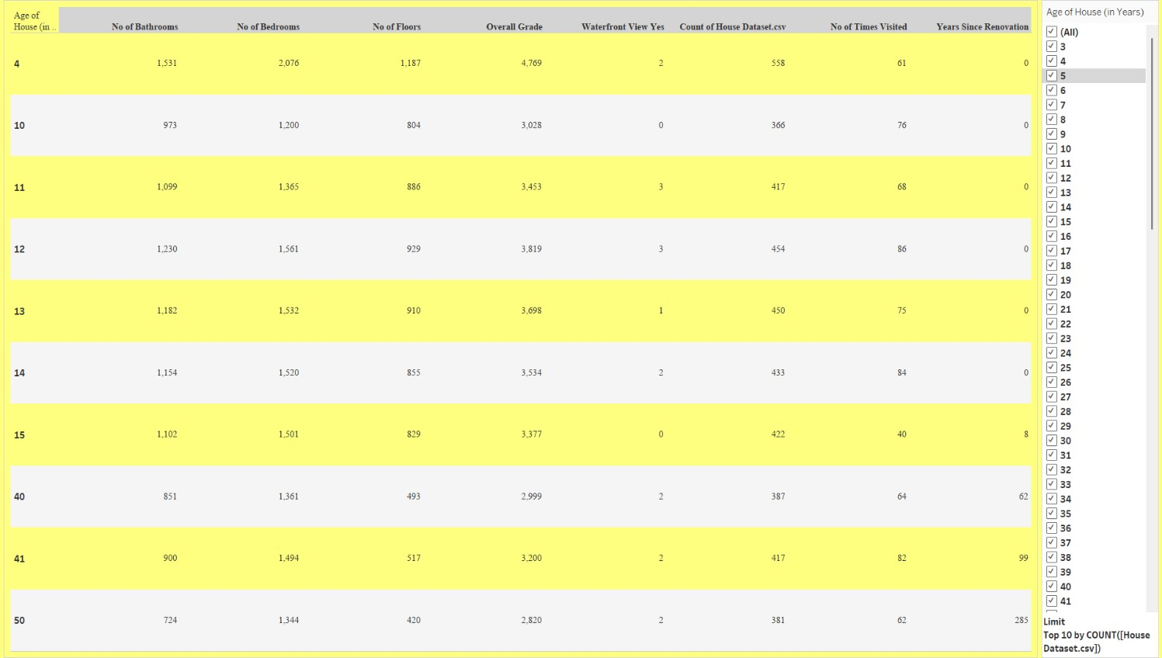

- Which price bins have the least number of houses?

Visualization: Horizontal bar chart shows the least number of houses.

